Ditshupo Environmental Engineering: Technical Report

Prepared by: Nkosinathi Mdala
Student Number: 43235735

1. Executive Summary
This technical report documents the design, implementation and testing of a computer network for Ditshupo Environmental Engineering, an environmental consultancy based in Kimberley, Northern Cape. The network serves approximately 420 staff across a main office and two satellite offices, using the address block 172.30.44.0/23.
The network was built and simulated in Cisco Packet Tracer. It uses a hierarchical (extended star) topology with one core multilayer switch, eight access switches and one edge router. The core switch performs inter-VLAN routing, DHCP and access control. The edge router provides internet access through Network Address Translation with Port Address Translation, which is the assigned networking feature for this project.
The core network is fully implemented and verified: VLAN segmentation, trunking, inter-VLAN routing, DHCP, Guest isolation, wireless Guest Wi-Fi, server segment and NAT/PAT. The site-to-site VPN intended for field staff is only partially working.

2. Client background and requirements
Ditshupo Environmental Engineering handles mine rehabilitation, large-scale water quality monitoring, environmental impact assessments, soil and groundwater remediation and ongoing compliance monitoring for mining, municipal and industrial clients.
The design review identified these requirements:
- Segmentation of departments (administration, laboratory, GIS/CAD, scientists and compliance, servers, guests, satellite offices) so that sensitive systems are separated from general and guest traffic.
- Reliable internet access for all internal staff.
- A guest wireless network that reaches the internet but cannot reach internal systems.
- Connectivity to two satellite offices in Kimberley.
- Secure access for field staff working remotely.
- Room for growth and low day-to-day maintenance, since IT support is part-time.

3. Network design

3.1 Topology
The network uses an extended star topology, where the core multilayer switch sits at the center, with each access switch connected to it by its own uplink. This keeps faults contained (a failed access switch affects only its own department), keeps the design simple to troubleshoot and lets new access switches be added without redesigning the core.
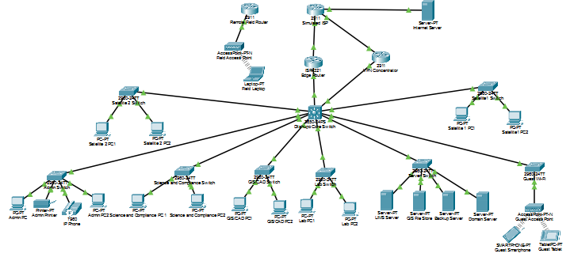
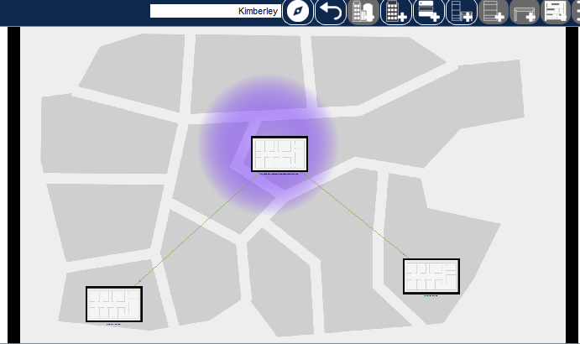

3.2 Physical layout
The main office houses the wiring closet containing the core switch, edge router, six main-office access switches and the servers. The Guest access point, printer and IP phone are in the main office. Each satellite office is a separate building with its own access switch and PCs, linked back to the core switch by a single point-to-point uplink. In a real deployment these links would run over leased line or fibre; the simulation uses a short copper run.

3.3 Design decisions and justification

Decision | Justification
One VLAN per department | Limits broadcast domains and allows access control between departments.
Inter-VLAN routing on the core multilayer switch | One device performs all Layer 3 work, so access switches stay simple and low-maintenance.
DHCP served by the core switch | Avoids a separate DHCP server and keeps addressing centrally managed.
Static addressing for servers and infrastructure | Servers need predictable addresses for clients and DNS.
Unused native VLAN (999) on all trunks | Reduces the risk of VLAN hopping.
Access control list on the Guest VLAN | Gives Guest users and staff members(cleaning and security staff) limited internet access while segregating them from internal networks.
PAT on the edge router | One public address serves all internal hosts, with no need for a public address block.
Dedicated transit subnets between infrastructure devices | Prevents address overlap with client VLANs.

4. IP addressing plan
The block 172.30.44.0/23 was divided with variable-length subnet masking (VLSM), sizing each subnet to its department.
VLAN | Segment | Network | Mask | Gateway | Usable hosts
10 | Admin, PM, HR and Finance | 172.30.44.0/25 | 255.255.255.128 | 172.30.44.1 | 126
70 | Field VPN pool | 172.30.44.128/26 | 255.255.255.192 | 172.30.44.129 | 62
40 | Laboratory | 172.30.44.192/26 | 255.255.255.192 | 172.30.44.193 | 62
20 | Environmental scientists and compliance | 172.30.45.0/26 | 255.255.255.192 | 172.30.45.1 | 62
30 | GIS/CAD | 172.30.45.64/26 | 255.255.255.192 | 172.30.45.65 | 62
60 | Guest Wi-Fi | 172.30.45.128/27 | 255.255.255.224 | 172.30.45.129 | 30
80 | Satellite site 1 | 172.30.45.160/27 | 255.255.255.224 | 172.30.45.161 | 30
90 | Satellite site 2 | 172.30.45.192/27 | 255.255.255.224 | 172.30.45.193 | 30
50 | Servers | 172.30.45.224/28 | 255.255.255.240 | 172.30.45.225 | 14
99 | Network management | 172.30.45.240/28 | 255.255.255.240 | 172.30.45.241 | 14
The design review addressing table did not reserve a link between the core switch and the edge router. Because a subnet can be assigned to only one interface, borrowing spare VLAN 99 addresses caused an overlap error during the build. Infrastructure links therefore use their own subnets outside the client block:
Link | Subnet | Addresses
Core switch to edge router | 192.168.100.0/30 | Core .1, edge router .2
Core switch to VPN concentrator | 192.168.101.0/30 | Core .1, concentrator .2

The simulated internet side uses documentation address ranges:
Link | Address
ISP to edge router | 203.0.113.1/30 (ISP), 203.0.113.2/30 (edge router outside)
ISP to internet server | 198.51.100.1/24 (ISP), 198.51.100.10/24 (server)
ISP to VPN concentrator | 203.0.113.5/30 (ISP), 203.0.113.6/30 (concentrator)
ISP to remote field router | 203.0.113.9/30 (ISP), 203.0.113.10/30 (field router)

5. Implementation

5.1 Devices
Role | Model | Notes
Core switch | Catalyst multilayer switch (3650-series) | Routing, DHCP, ACLs
Edge router | ISR 4321 | NAT/PAT
ISP router | 2911 with HWIC-1GE-SFP and GLC-T | Simulates the internet
VPN concentrator, remote field router | 2911 | Site-to-site tunnel
Access switches (8) | 2960-24TT | Layer 2 only
Wireless access point | AP-PT-N | Guest Wi-Fi

5.2 VLANs and trunking
Each access switch carries only its own VLAN plus the native VLAN on its uplink. The core switch ports are:
Core port | Connects to | VLAN
Gi1/0/1 | Laboratory switch | 40
Gi1/0/2 | GIS/CAD switch | 30
Gi1/0/3 | Science and compliance switch | 20
Gi1/0/4 | Server switch | 50
Gi1/0/5 | Admin switch | 10
Gi1/0/6 | Satellite 2 switch | 90
Gi1/0/7 | Edge router (routed port) | transit
Gi1/0/8 | Satellite 1 switch | 80
Gi1/0/9 | Guest switch | 60
Gi1/0/10 | VPN concentrator (routed port) | transit
End-user access ports use port security with a maximum of two MAC addresses and the restrict violation mode.
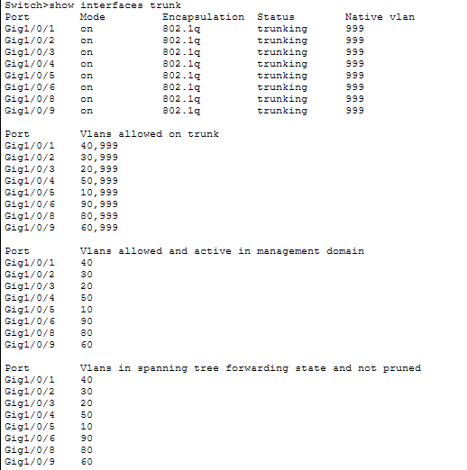
Figure 3: show interfaces trunk command on the core multilayer switch

5.3 Inter-VLAN routing and DHCP
IP routing is enabled on the core switch, with one switch virtual interface (SVI) per VLAN acting as that VLAN's gateway. One DHCP pool exists for each client VLAN. The gateway address and a small range for static devices are excluded from each pool. Servers and management devices are addressed statically.
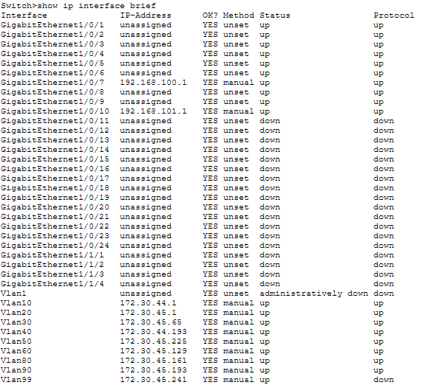Figure 4: show ip interface brief on the core multilayer switch
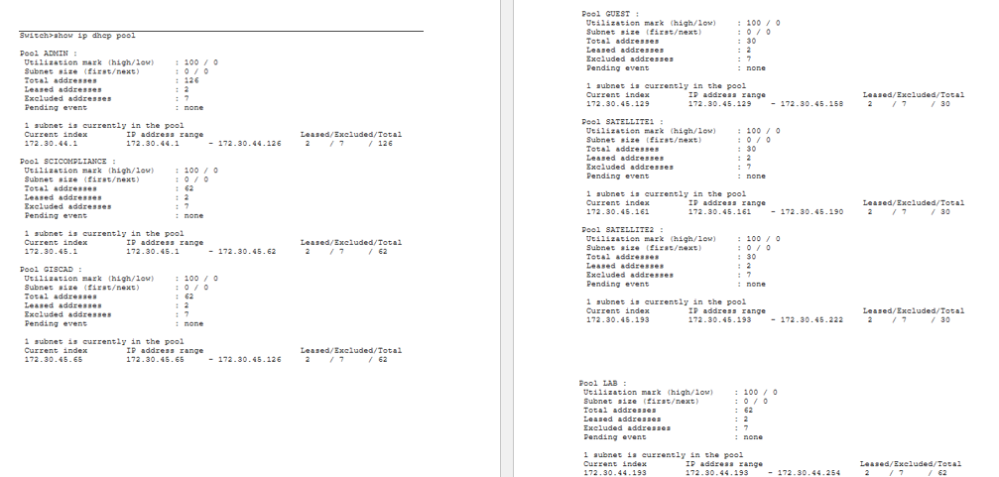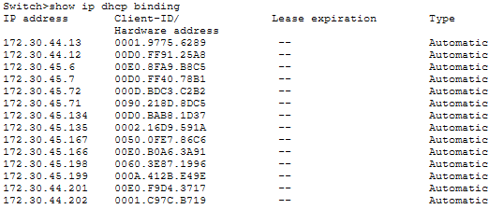

5.4 Guest isolation
An extended ACL named GUEST-ISOLATION is applied inbound on the VLAN 60 interface. It permits DHCP and DNS first, denies traffic from the Guest subnet to the internal block 172.30.44.0/23 and permits everything else, so Guest users still reach the internet. Order matters because ACLs are evaluated top-down and stop at the first match.

5.5 Guest Wi-Fi
The access point is a Layer 2 bridge connected to the Guest switch (VLAN 60). It uses the SSID "Ditshupo Guest Wi-Fi" with WPA2-PSK and AES. Wireless clients receive addresses from the Guest DHCP pool and are subject to the same isolation ACL as wired Guest devices.

5.6 Servers
The server segment (VLAN 50) holds the LIMS, GIS file store, backup and domain/DNS servers, each with a static address in 172.30.45.226 to 172.30.45.238.

6. Assigned feature: NAT/ PAT

6.1 What it does
Internal hosts use private addresses, which cannot be routed on the public internet. The edge router translates each internal source address to its own outside address (203.0.113.2) and distinguishes sessions by port number. This is PAT, also called NAT overload.

6.2 Configuration
- ip nat inside on the interface facing the core switch (GigabitEthernet0/0/0).
- ip nat outside on the interface facing the ISP (GigabitEthernet0/0/1).
- access-list 1 permits 172.30.44.0 0.0.1.255, the whole internal block.
- ip nat inside source list 1 interface GigabitEthernet0/0/1 overload performs the translation.
- The edge router has a default route to the ISP and a static route back to 172.30.44.0/23 via the core switch. The core switch has a default route to the edge router.
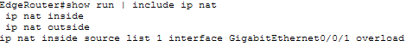

6.3 Why Port Address Translation?
The design has one public-facing address and several hundred internal hosts that only need to start outbound connections. Static NAT would need one public address per host, and a dynamic pool would need a block of public addresses. PAT meets the requirement with a single address and no extra cost or maintenance.

6.4 Verification
Evidence collected:
- The translation table is empty before any traffic is generated.Figure 7: translation table is empty before any traffic
- After pinging the internet server, the table shows private addresses mapped to 203.0.113.2 with port numbers. 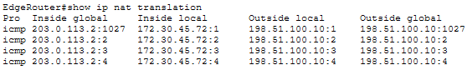
- Pings from PCs in several VLANs (GIS/CAD, Laboratory, Science and Compliance) show several private addresses sharing one public address, which is the clearest proof of PAT.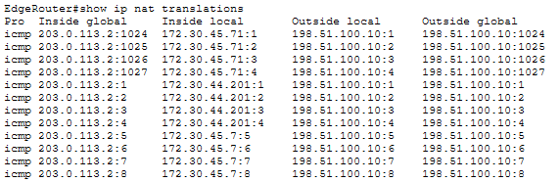
- show ip nat statistics shows non-zero hits, with GigabitEthernet0/0/0 as inside and GigabitEthernet0/0/1 as outside. 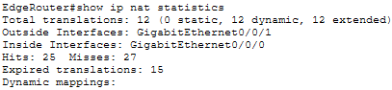
- A Simulation-mode packet trace shows the source address changing at the edge router. This is demonstrated in the accompanying video.

7. Testing and verification
Testing followed the same sequence for every VLAN, working from the end device outward: address and gateway, access port VLAN, trunk, SVI state, route, then NAT.
Test | Expected result | Result
Each client PC receives a DHCP address in its own subnet | Correct address, mask and gateway | Pass for all VLANs
Ping between VLANs (for example Admin to Laboratory) | Replies received | Pass
Ping from each VLAN to 198.51.100.10 | Replies received via NAT | Pass
Guest to internal address | Blocked | Pass
Guest to internet server | Replies received | Pass
Wireless phone and tablet on Guest | Address from Guest pool, isolated, internet reachable | Pass
Servers reachable from internal PCs | Replies received | Pass
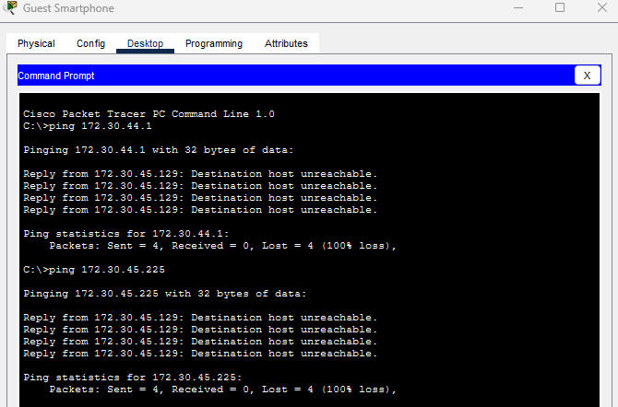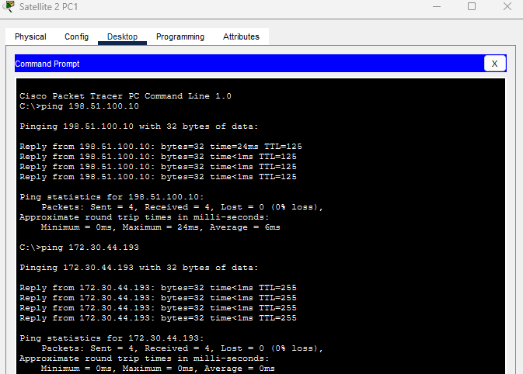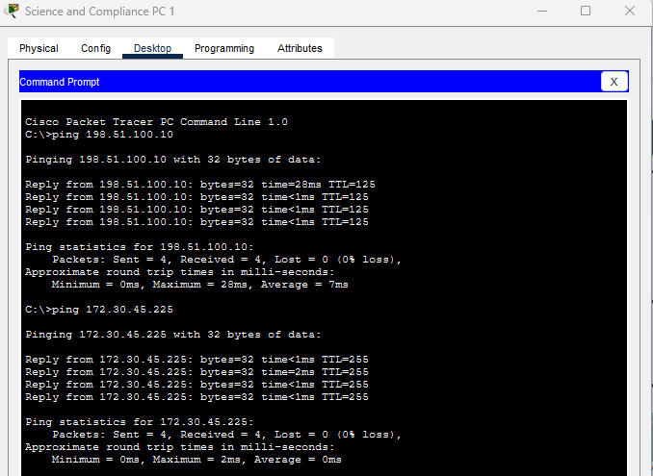
The ACL hit counters on the Guest isolation rules increased during testing, confirming the rules were being matched and not merely configured.

8. Issues encountered and resolutions
The full fault-finding procedure is in the separate troubleshooting document. The main faults and their causes are summarized here.
Symptom | Root cause | Resolution
SVIs up but protocol down | Trunk allowed-VLAN lists were copied between ports and carried the wrong VLAN | Corrected each trunk's allowed list, then reset the SVI
PC receives no DHCP address | DHCP pool missing for that VLAN (Lab, then others) | Created the missing pools
One PC works, its neighbor does not | Neighbor's access port left in VLAN 1 (Admin, Science and Compliance) | Assigned the correct VLAN to the port
Edge router and core switch could not communicate | Transit addresses overlapped the VLAN 99 subnet | Moved the transit link to its own /30
Internet unreachable after a router swap | ISP router configuration lost and rebuilt | Rebuilt the ISP on a 2911 with a routed Gigabit module
ip address rejected on module ports | NIM-ES2-4 is a Layer 2 switch module | Replaced with HWIC-1GE-SFP and a GLC-T transceiver
VPN concentrator not seen by CDP | Inside and outside cables were swapped | Recabled to the correct interfaces

9. Known limitations
- Field VPN: A site-to-site IPsec tunnel stands in for field-staff remote access, since Packet Tracer cannot run a VPN client. Phase 1 (ISAKMP) establishes and outbound traffic is encrypted and delivered. Return traffic from the head office through the tunnel was not completed, so the feature is not fully working.
- VLAN 99: The management SVI shows protocol down because no trunk carries the VLAN. Nothing depends on it yet.
- Scale: The simulation uses a representative sample of devices per VLAN. The subnets are sized for the full headcount.

10. Conclusion
The network meets the core requirements of the client brief: departments are segmented, internal users and guests reach the internet through PAT, guests are isolated from internal systems and wireless access works. The assigned NAT feature is implemented, verified and demonstrated. The remaining features were unfortunately too complex to complete on time.

